Transcript

Source S0052

Coroner’s Inquest
Westmoreland County, Virginia, Deeds and Wills 1665-1677, p. 79

"Westmoreland, Virginia, United States Records," images, FamilySearch (https://www.familysearch.org/ark:/61903/3:1:3Q9M-C9PR-RTTC : April 10, 2023), image 278 of 593; Virginia. County Court (Westmoreland County).

Date Accessed: 10 Apr 2023

Transcript
Coroner’s Inquest on Marton Jole
March 2nd 1670, a jury impanelled upon +++ board of Martin Colos Mr. John App+++ coroner the jurors verdict with their hands sub+++ under oath +++. The corps being examined by the jurors and they all agreed for their +++ that the said Marton Sole was accidently drowned.
Mark of Robt. Sanford (among others)

Document Image

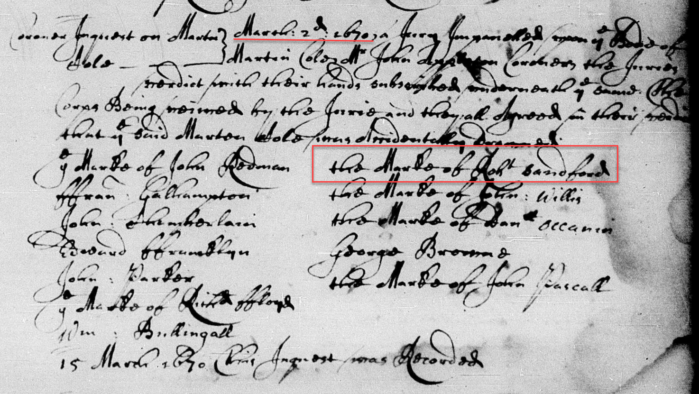

Analysis
Robert Sanford was living in Westmoreland County as of 2 Mar 1670.

